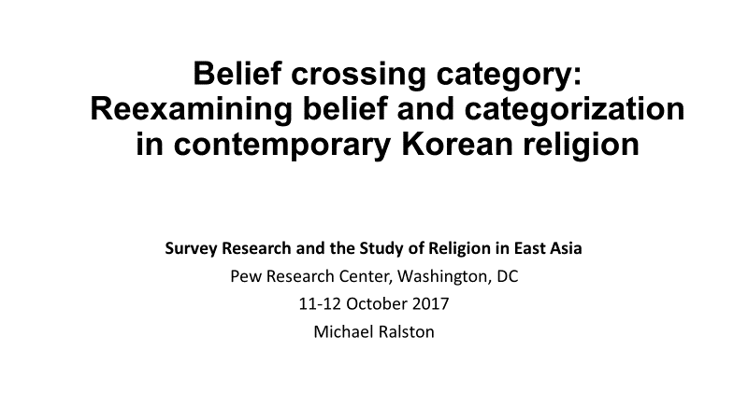
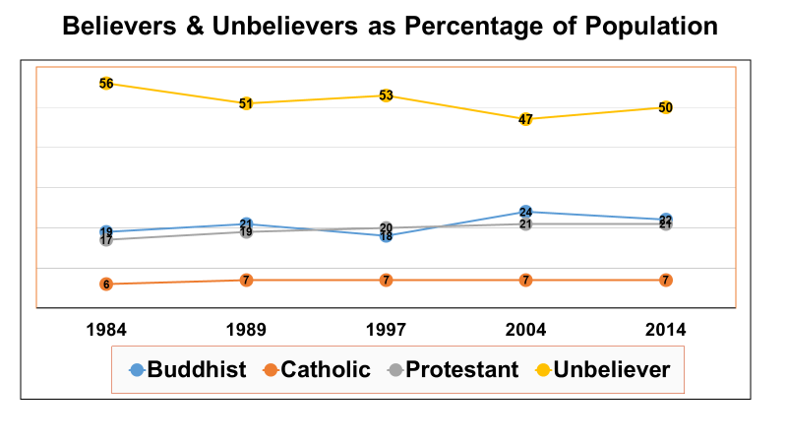
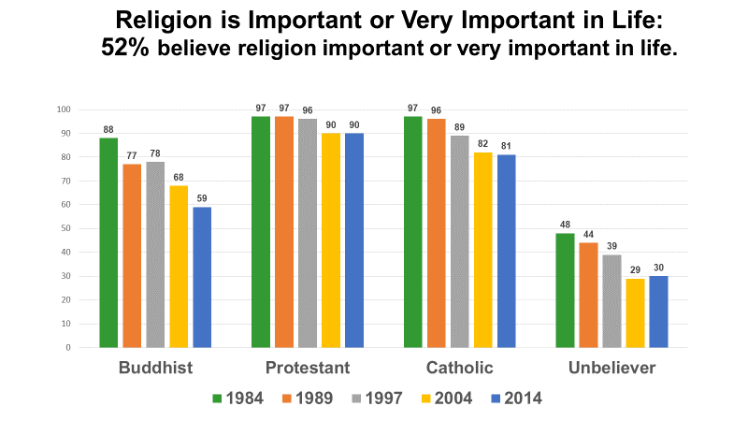

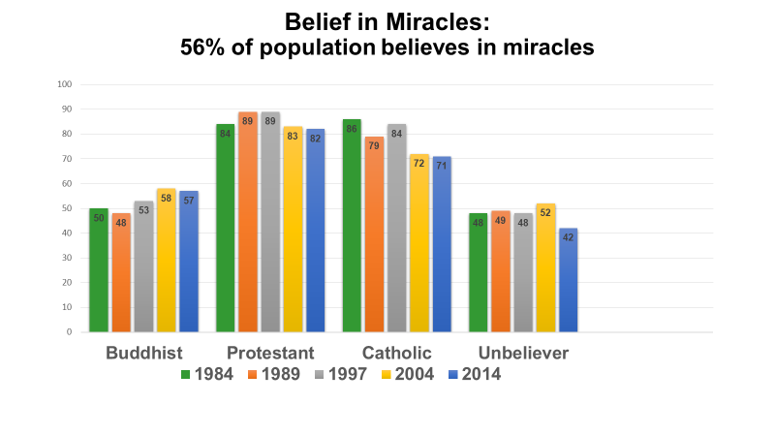

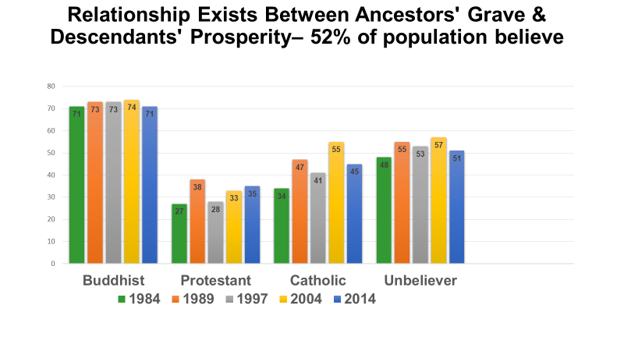
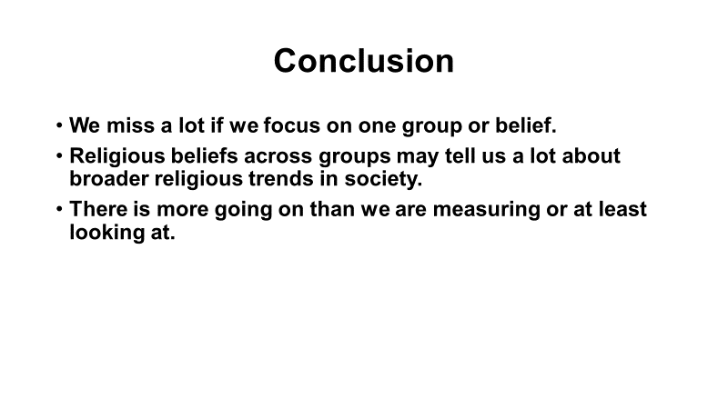

Belief Crossing Category: Reexamining Belief and Categorization in
Contemporary Korean Religion

Abstract: Gallup Korea conducted surveys of the South Korean religious landscape covering thirty years, starting in 1984 with the most recent in 2014. Survey results from 2014 show Korean society evenly divided between people claiming a religious affiliation and unbelievers (people who are either non-religious or religious but unaffiliated, etc.). The religious population in Korea is also close to evenly split between Buddhists, who comprise 22% of total population, and Christians, with 21% of the population being Protestant and 7% Catholic. Analyses tracking religious belief in Korea often focus on Protestants, Catholics, or Buddhists and the changes between or within these groups. Little research is conducted on a fourth group, unbelievers. In addition, often ignored are common beliefs across these four groups. For example, over 50% of respondents stated religion is important or very important in life, but this result does not correspond with the split in society between believers and unbelievers. Some believers do not hold this view while 30% of unbelievers do. Likewise for belief in miracles—82% of Protestants believe in miracles, but so do 42% of unbelievers.
Expanding the analysis of data to broaden perspectives sheds light on understudied aspects of religion and belief in modern South Korea by revealing some beliefs shared, to different extents, between religious people (Christians or Buddhists) or unbelievers and highlights trends that cross religious boundaries in contemporary Korean society. It also reveals methodological problems with categorization in general, the categories “unbelievers,” “non-religious,” and “nones,” in particular, and the need for discussion on capturing beliefs that cross boundaries.

Religious issues (based on 2014 survey results):

1. 52% of population believe religion important or very important in life.
Buddhist: 59% Protestant: 90% Catholic: 81% Unbelievers: 30%

2. 56% of population believes in miracles
Buddhist: 57% Protestant: 82% Catholic: 71% Unbelievers: 42%

3. 52% of population believe a relationship exists between ancestors' grave & descendants' prosperity.
Buddhist: 71% Protestant: 35% Catholic: 45% Unbelievers: 51%

4. 60% of population think people believe in religion to achieve peace of mind.
Buddhist: 67% Protestant: 49% Catholic: 58% Unbelievers: 62%

5. 70% of population think that although teachings of religions differ, the religions are, ultimately, talking about the same or similar truths.
Buddhist: 79% Protestant: 49% Catholic: 79% Unbelievers: 74%

6. 59% of population think believing in religion improves quality of life.
Buddhist: 67% Protestant: 84% Catholic: 73% Unbelievers: 43%

7. 67% of population think believing in religion is good but they dislike being tied to a religious organization.
Buddhist: 67% Protestant: 52% Catholic: 65% Unbelievers: 75%

8. 63% of population think religion has recently helped society some or a great deal.
Buddhist: 67% Protestant: 87% Catholic: 79% Unbelievers: 48%

9. 63% of population think that if a couple’s fortune (prediction of marriage compatibility) is bad, it is irrelevant and should not prevent them from marrying.
Buddhist: 48% Protestant: 72% Catholic: 68% Unbelievers: 66%

10. 60% of population does not believe in judgement by a supreme being.
Buddhist: 65% Protestant: 31% Catholic: 45% Unbelievers: 71%

11. 52% of population does not believe in creation by a supreme being.
Buddhist: 51% Protestant: 33% Catholic: 42% Unbelievers: 61%

12. 65% of population disagree with the statement, “However fervent one’s belief, it does no good if you do no attend church or a temple.”
Buddhist: 74% Protestant: 46% Catholic: 64% Unbelievers: 69%

13. 93% of population think there are a lot or some pseudo-religions in their neighborhood that cannot be called religious.
Buddhist: 92% Protestant: 93% Catholic: 97% Unbelievers: 93%

14. 53% of population do not believe in reincarnation.
Buddhist: 44% Protestant: 54% Catholic: 54% Unbelievers: 57%

15. 67% of population disagree with the statement, “No matter how good a person is, if the person does not believe in religion, he/she cannot go to heaven or paradise.”
Buddhist: 75% Protestant: 36% Catholic: 67% Unbelievers: 76%

Social issues (based on 2014 survey results):

1. 54% of population disagree with the idea that there should be a distinction between the work husbands and wives have to do.
Buddhist: 45% Protestant: 59% Catholic: 63% Unbelievers: 55%

2. 64% of population disagree with the idea that children should follow the will of their parents instead of their own ideas.
Buddhist: 59% Protestant: 62% Catholic: 67% Unbelievers: 67%

3. 75% of population agree that, depending on the circumstances, people should be able to divorce.
Buddhist: 73% Protestant: 68% Catholic: 73% Unbelievers: 79%

4. 60% of population agree women should be able to terminate an unwanted pregnancy.
Buddhist: 62% Protestant: 51% Catholic: 58% Unbelievers: 63%

5. 76% of population disapprove of homosexuality.
Buddhist: 84% Protestant: 83% Catholic: 72% Unbelievers: 70%

