NUMBERS, FACTS AND TRENDS SHAPING THE WORLD

FOR RELEASE DECEMBER 18, 2014

Many in Emerging and Developing Nations Disconnected from Politics
Participation Highest in Middle East
FOR FURTHER INFORMATION
ON THIS REPORT:
Richard Wike, Director, Global Attitudes Research
Russ Oates, Senior Communications Manager
202.419.4372
www.pewresearch.org

RECOMMENDED CITATION: Pew Research Center, December, 2014, “Many in Emerging and Developing Nations Disconnected from Politics”

About the Report
This report examines patterns of political participation in a variety of activities, including voting, protesting and online engagement in emerging and developing nations. It also looks at political efficacy and the perceived effectiveness of these political activities in these countries. It is based on 37,620 face-to-face interviews in 33 countries with adults 18 and older conducted from March 17 to June 5, 2014. For more details, see survey methods and topline results.

The report is a collaborative effort based on the input and analysis of the following individuals:
Jill Carle, Research Associate
Richard Wike, Director, Global Attitudes Research

James Bell, Director, International Survey Research Danielle Cuddington, Research Assistant
Claudia Deane, Director, Research Practice Kat Devlin, Research Analyst
Bruce Drake, Senior Editor Michael Keegan, Information Graphics Designer
Bridget Parker, Research Assistant Jacob Poushter, Research Associate
Steve Schwarzer, Research Methodologist Katie Simmons, Senior Researcher
Bethany Smith, Administrative Coordinator Bruce Stokes, Director, Global Economic Attitudes
Hani Zainulbhai, Research Analyst

About Pew Research Center
Pew Research Center is a nonpartisan fact tank that informs the public about the issues, attitudes and trends shaping America and the world. It does not take policy positions. It conducts public opinion polling, demographic research, media content analysis and other empirical social science research. The center studies U.S. politics and policy views; media and journalism; internet and technology; religion and public life; Hispanic trends; global attitudes and U.S. social and demographic trends. All of the center’s reports are available at www.pewresearch.org. Pew Research Center is a subsidiary of The Pew Charitable Trusts.
Michael Dimock, President
Elizabeth Mueller Gross, Vice President
Robyn Tomlin, Chief Digital Officer
Andrew Kohut, Founding Director

© Pew Research Center 2014
Many in Emerging and Developing Nations Disconnected from Politics
Participation Highest in Middle East
In recent years, high-profile protest movements have erupted in several emerging and developing countries, roiling, and sometimes overturning, the political status quo in Tunisia, Egypt, Turkey, Ukraine, Brazil, Thailand and other nations. Millions have demonstrated, and activists have pioneered new forms of online engagement.
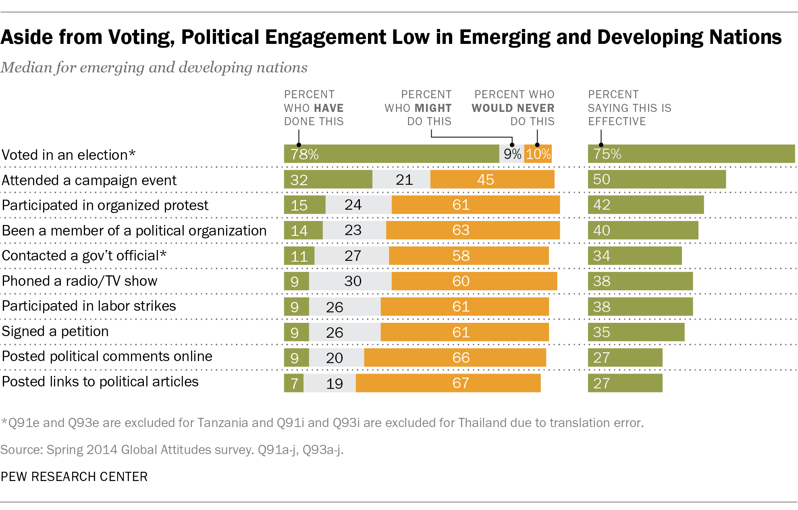
However, a recent Pew Research Center survey finds that many people in these nations remain relatively disconnected from politics. Although most vote in elections, few take part in other forms of political participation. For example, across 33 nations surveyed, a median of just 15% say they have participated in a protest and only 9% have signed a petition. Indeed, large numbers say they would never engage in the various forms of participation included in the poll.
Political engagement varies considerably among different demographic groups. The engaged are typically better educated and wealthier. Older people are more likely to vote, but younger people
High Participation in Middle East
Political participation by region
Note: “High participation” includes people who scored a 4.5 or higher on the political participation scale; “medium participation” includes people who scored between 2 and 4 on the political participation scale; “low participation” includes people who scored a 1.5 or less on the political participation scale. African median excludes Tanzania and Asian median excludes Thailand due to translation errors.
Source: Spring 2014 Global Attitudes survey. Q91a-j.
PEW RESEARCH CENTER
are more likely to participate in other ways, including online activism. Overall, few people say they post political comments or links to articles online, but these activities are much more common among 18-29 year-olds.
Voting is considered the most useful form of participation on the survey: A median of 75% say it is an effective way to influence what government does. No other type of engagement is considered effective by more than 50%, although many do consider as effective attending campaign events, participating in protests and being a member of a political organization. Young people are more likely than their older counterparts to believe that many forms of political participation are effective, and in particular they are often more likely to say protesting is an effective way to influence government.
The Middle East stands out among the regions surveyed for its relatively high rates of participation. In the home of the Arab Spring and its aftermath, a median of 53% fall into the “high” category of our participation index. Egypt, in particular, stands out. Twice in recent years, Egyptians have poured into the streets to oust a president – Hosni Mubarak in 2011 and Mohamed Morsi in 2013 – and 47% of Egyptians say they have participated in a protest at some point, the highest percentage among the nations surveyed. Morsi’s removal from office was ignited in part by a petition drive organized by the Tamarod movement, and 50% of Egyptians report having signed
Relatively High Participation in Middle East, Africa; Low in Latin America, Asia
Political participation by country
Note: Tanzania and Thailand are excluded due to translation errors. “High participation” includes people who scored a 4.5 or higher on the political participation scale; “medium participation” includes people who scored between 2 and 4 on the political participation scale; “low participation” includes people who scored a 1.5 or less on the political participation scale.
Source: Spring 2014 Global Attitudes survey. Q91a-j.
PEW RESEARCH CENTER
a political petition, by far the highest percentage registered in the survey. Egypt is also at the top of the list for the percentage of people who have been active members of a political organization, phoned a radio or television show to express an opinion and participated in a labor strike.
Overall, political engagement is closely linked to an individual’s faith in government and belief that he or she can have an influence on political matters, or what scholars sometimes refer to as political efficacy. People who believe politicians care what they think participate in more political activities. Moreover, people who think a specific form of participation – protesting, for example – is effective are more likely to take part in that activity.
A median of just 19% of those surveyed believe that government officials care what they think. While relatively low, this is comparable to figures from a 2014 Pew Research Center poll in the United States where 20% of Americans say elected officials care what people like them think.
These are among the key findings of a recent survey by the Pew Research Center, conducted in 33 emerging and developing countries among 37,620 respondents from March 17 to June 5, 2014. Overall, the study finds that participation rates vary significantly across the nations polled. Obviously, opportunities for political participation also vary widely across these nations, depending on the frequency of elections, the development of civil society organizations, and the presence of a political environment that permits free expression.

Participation Higher in Middle East, Africa
In addition to Egypt, political participation is also relatively high in several of the other Middle Eastern nations surveyed, including Jordan, Lebanon and the Palestinian territories. Tunisia has the lowest levels in the region, with just 17% reporting high political engagement, despite the fact that its 2011 Jasmine Revolution was the first of the Arab Spring anti-government protests. Along with Middle Easterners, Africans also report high levels of political engagement. Six-in-ten Kenyans are in the high participation category, as are 52% of Senegalese. Ghanaians report the lowest participation in the region, with just 24% among the highly-engaged political participants.
There is relatively little variation across Latin American nations. About three-in-ten people in six of the nine countries surveyed report high levels of political participation. Nicaraguans report the highest levels of engagement (42%), while Salvadorans are the least likely to participate (22%).
Involvement in politics is somewhat less prevalent in Asia. While about two-thirds of Bangladeshis (65%) report higher levels of participation, other Asian publics are less apt to participate. Pakistan (12%) is home to the lowest level of political engagement among the 30 countries included in the index. Indonesia (20%), the Philippines (21%) and Malaysia (26%) also have relatively low participation rates.
The formerly communist Eastern European nations included in the survey also report fairly low levels of participation. Just 37% of Poles 28% of Ukrainians and 27% of Russians participate at high levels.

Voting Most Common, Posting Views Online Least
Voting is by far the most frequent mode of political engagement in the countries polled, with a median of 78% saying they have voted. Voter participation is highest in Asia and Latin America (each with a median of 85%). Large numbers also say they have voted in Africa (77%) and the three Eastern European countries surveyed – Poland (75%), Russia (76%) and Ukraine (79%). Voting is
Political Engagement
People who have __ in the past
 | Voted in an election | Attended a campaign event or speech | Participated in an organized protest | Been an active member of a political organization | Contacted a gov’t official | Participated in labor strikes | Signed a petition about a political issue | Phoned a radio/TV show to express an opinion | Posted online comments on political issues | Posted online links to political articles
Middle East | % | % | % | % | % | % | % | % | % | %
Turkey | 78 | 17 | 12 | 10 | 7 | 11 | 9 | 7 | 13 | 13
Lebanon | 63 | 38 | 36 | 25 | 11 | 18 | 13 | 9 | 18 | 17
Tunisia | 63 | 22 | 13 | 5 | 7 | 14 | 7 | 4 | 13 | 9
Jordan | 59 | 35 | 22 | 29 | 16 | 19 | 6 | 29 | 13 | 15
Palest. ter. | 54 | 35 | 26 | 21 | 11 | 15 | 14 | 20 | 26 | 23
Egypt | 53 | 46 | 47 | 41 | 23 | 36 | 50 | 39 | 6 | 7
MEDIAN | 61 | 35 | 24 | 23 | 11 | 17 | 11 | 15 | 13 | 14
Africa
Ghana | 81 | 40 | 10 | 21 | 6 | 9 | 2 | 10 | 4 | 4
Uganda | 79 | 59 | 18 | 32 | 30 | 6 | 7 | 16 | 6 | 5
Kenya | 78 | 65 | 24 | 26 | 19 | 16 | 7 | 21 | 12 | 11
Senegal | 75 | 53 | 23 | 28 | 12 | 8 | 8 | 14 | 8 | 7
South Africa | 71 | 28 | 15 | 17 | 6 | 11 | 8 | 11 | 8 | 7
Nigeria | 70 | 36 | 20 | 24 | 11 | 18 | 4 | 16 | 14 | 10
Tanzania | -- | 48 | 10 | 20 | 31 | 4 | 11 | 9 | 5 | 4
MEDIAN | 77 | 48 | 18 | 24 | 12 | 9 | 7 | 14 | 8 | 7
Latin America

Brazil | 94 | 34 | 9 | 4 | 5 | 7 | 13 | 5 | 9 | 7
Venezuela | 91 | 31 | 12 | 19 | 12 | 8 | 7 | 13 | 14 | 12
Nicaragua | 90 | 47 | 17 | 28 | 15 | 9 | 14 | 9 | 9 | 7
Argentina | 89 | 24 | 15 | 10 | 10 | 10 | 13 | 8 | 13 | 11
Peru | 85 | 23 | 15 | 7 | 5 | 11 | 4 | 7 | 5 | 4
El Salvador | 82 | 27 | 8 | 10 | 5 | 4 | 3 | 6 | 8 | 6
Colombia | 76 | 37 | 9 | 8 | 9 | 8 | 10 | 5 | 9 | 7
Chile | 74 | 24 | 27 | 10 | 7 | 17 | 10 | 7 | 15 | 13
Mexico | 71 | 25 | 11 | 8 | 5 | 4 | 5 | 4 | 7 | 6
MEDIAN | 85 | 27 | 12 | 10 | 7 | 8 | 10 | 7 | 9 | 7
Asia
Thailand | 96 | 19 | 11 | 7 | -- | 3 | 7 | 5 | 9 | 8
Indonesia | 89 | 21 | 5 | 6 | 5 | 4 | 2 | 5 | 3 | 4
India | 88 | 33 | 19 | 14 | 22 | 17 | 14 | 9 | 6 | 7
Philippines | 85 | 37 | 10 | 14 | 14 | 8 | 9 | 8 | 8 | 8
Bangladesh | 78 | 48 | 37 | 32 | 33 | 31 | 22 | 24 | 20 | 21
Malaysia | 71 | 30 | 9 | 13 | 14 | 5 | 7 | 7 | 7 | 6
Pakistan | 69 | 13 | 7 | 4 | 8 | 6 | 4 | 1 | 1 | 2
MEDIAN | 85 | 30 | 10 | 13 | 14 | 6 | 7 | 7 | 7 | 7
Eastern Europe
Ukraine | 79 | 19 | 18 | 7 | 19 | 9 | 10 | 3 | 7 | 6
Russia | 76 | 12 | 7 | 8 | 20 | 6 | 11 | 8 | 8 | 6
Poland | 75 | 20 | 16 | 10 | 35 | 14 | 31 | 9 | 9 | 8
GLOBAL MEDIAN | 78 | 32 | 15 | 14 | 11 | 9 | 9 | 9 | 9 | 7
Note: Q91e is excluded for Tanzania and Q91i is excluded for Thailand due to translation error.
Source: Spring 2014 Global Attitudes survey. Q91a-j.
PEW RESEARCH CENTER
much less common in the Middle East, where the opportunity to vote is often less frequent because of government instability and suffrage limitations. Across the region, when asked if they have voted in the last 12 months or in the more distant past, just 61% say they have voted. Lebanon and the Palestinian territories have not held national elections in five or more years.
A median of 32% in the nations surveyed say they have attended a political campaign event or speech. Attendance is greatest in African nations, where 48% report participating in such events. Going to campaign events is less prevalent in the Middle East, Asia, Latin America and especially the Eastern European nations surveyed – just 12% of Russians, 19% of Ukrainians and 20% of Poles say they have gone to a campaign event or speech.
Fewer people report participating in an organized protest of any kind (a median of 15% of those surveyed), being an active member of a political organization (14%) or contacting a government official (11%). Generally, Middle Easterners and Africans are more likely to engage in protests or join political groups than Latin American, Asian or Eastern European publics. Communication with public officials is highest in the Eastern European countries surveyed – roughly a third of Poles (35%) report contacting a government official.
Relatively few people around the world have participated in labor strikes, signed a petition or phoned a live radio or TV show to express an opinion (a median of 9% for each). While few participate in these ways, Middle Easterners more frequently engage in the political system through labor strikes and call-in shows than their counterparts elsewhere.
Across emerging and developing markets, just 7% say they have posted links to political stories or articles for others to read online, while 9% have posted their own thoughts or comments on political or social issues online. In 12 of the countries surveyed, these activities garner the lowest participation of all the political engagement activities tested. In large part, this is due to limited access to the internet in many of these nations. Online political activism becomes a more significant activity when looking only at a country’s internet users. For example, in Senegal, 29% of internet users (those who say they use the internet at least occasionally or who report owning a smartphone) have posted political comments online while just 8% of all Senegalese say they have done this activity. Though online political engagement is very low in Asia, Africa and Latin America, it is somewhat higher in the Middle East where a median of 13% say they post online political comments and 14% post online political links.

Young Participate in Less Conventional Ways
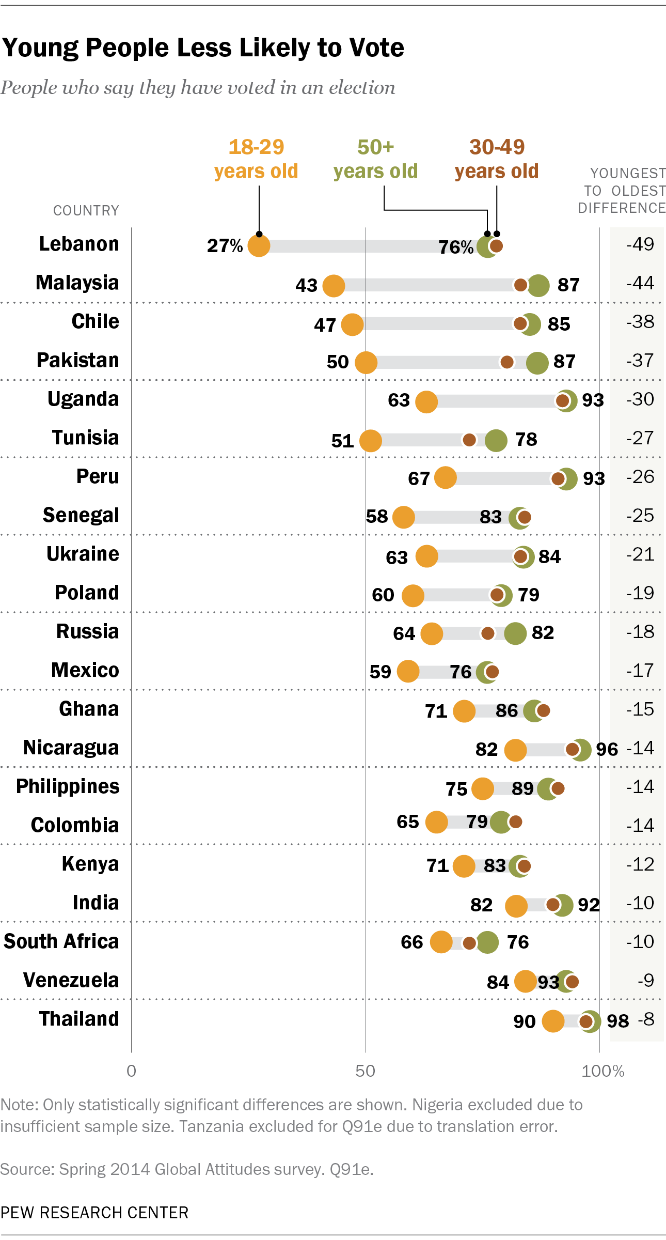
Young people are much less likely to engage in some traditional forms of political participation, including voting and contacting government officials. In 21 of 30 countries, young people are significantly less likely to vote compared with those age 50 and older, with differences of 15 percentage points or more in about half of the countries surveyed. In particular, there are dramatic age differences in voter participation in Lebanon, where 27% of 18-29 year olds say they have voted compared with 76% of those 50 and older – nearly a 50 point difference. This is potentially due to the lack of opportunity for younger voters since Lebanon has not held national legislative elections since June 2009. Young people are significantly less likely than those 50 and older to contact government officials in 11 of 30 countries, with some of the most substantial differences in Africa and Eastern Europe.
Though young people exercise their right to vote much less frequently, they often participate in less traditional ways than their older counterparts, especially through online activity. While relatively infrequent across all countries, young people are significantly more likely to engage in online political activity. This is due at least in part to the fact that younger people are also more likely to use the internet.
In 22 of 31 countries, 18 to 29 year olds are more likely to post links to political articles and post their own comments or thoughts about politics online. Some of the biggest age differences can be seen in the Palestinian territories where 35% of 18 to 29 years olds report posting political comments online, compared with just 9% of those 50 and older. About three-in-ten young Palestinians (31%) say they post links to political articles; only 8% of those 50 or older do the same.

Explaining Participation
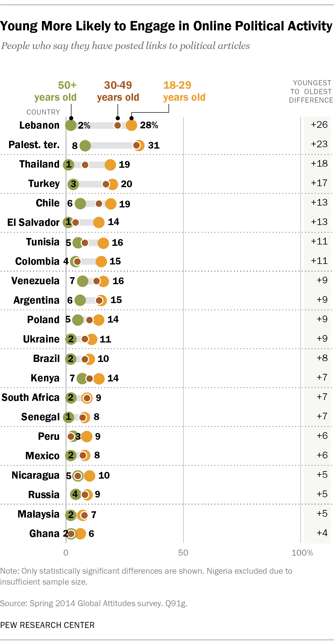
To further explore the relationship between demographics, political efficacy and overall political participation, we used a statistical technique called multivariate regression, which allowed us to test the individual impact of a number of factors on political participation while holding other variables constant (see Appendix for additional details). Overall, we find that education, political efficacy, gender and age have the biggest impact on whether someone participates in politics more frequently.
Education, political efficacy and gender have strong positive influences on individual political engagement. Those with a secondary education or higher, those who believe government officials care about their opinions and men participate in political activities at much higher rates. In addition to these factors, being employed and having a higher income also have a significant, positive impact on political engagement, though to a lesser degree.
Age also has a significant influence on political participation, controlling for other demographics. In emerging and developing markets, older people are significantly less likely than their younger counterparts to participate. While older people do vote more frequently than young people, they
Many Say Government Does Not Care
Most government officials __ what people like me think
Source: Spring 2014 Global Attitudes survey. Q94.
PEW RESEARCH CENTER
engage in some of the other political activities, particularly those done online, at lower rates than their younger counterparts in many countries.

Political Efficacy Low
On average, people in emerging and developing economies have low political efficacy. Majorities or pluralities in 31 of the 33 countries surveyed say that most government officials do not care what people like them think. This view is especially common in Latin America, where a median of 77% say their political opinions matter little to politicians, compared with just 13% who say government officials do care and 5% who volunteer that neither or both are true. The belief that government officials ignore average citizens is particularly strong among Brazilians, 90% of whom say their government does not care.
About two-thirds in the Middle East (67%) and Africa (65%) express doubts that political leaders pay attention to their opinions. In fact, South Africa is the only country surveyed in these two regions where fewer than half (43%) hold this view. Across these regions, roughly two-in-ten believe politicians care (19% in the Middle East, 20% in Africa).
Political efficacy in Eastern Europe is similarly low. More than seven-in-ten in the three nations surveyed believe that government officials care little about the views of people like them. Ukrainians have the lowest political efficacy with 83% saying that officials care little about their opinions.
Political efficacy is highest in Asia, but a median of 55% across the region still say that government officials do not care about what they think. Roughly a quarter (23%) believes politicians pay attention to their opinions, while 10% say neither. Filipinos far and away have the highest political efficacy of those surveyed. The Philippines is the only country in which at least half (52%) say government officials care about what people like them think. Still, more than a third (36%) believe politicians care little about their concerns, while 8% agree with neither or both.

Effectiveness of Political Participation
Among the forms of political engagement included on the survey, voting in an election is seen as the most effective way to influence what government does. A median of 75% across the emerging and developing economies polled say voting is very or somewhat effective. In every nation where the question was asked, voting holds the top spot among the 10 political activities included. Voting is viewed as a successful means for influencing the political process in Asia, where a median of 80% believe it is effective, though Africans and Latin Americans are not far behind (78% and 74%, respectively). Two-thirds of Middle Easterners also agree that voting is a useful tool in shaping government outcomes. Those in the Eastern European nations surveyed have quite varied opinions of the impact of the franchise. Three-quarters of Ukrainians say voting is an effective way to influence government, while just 51% of Poles say the same – the lowest of any country surveyed.
A median of 50% say that attending campaign events or speeches is an effective means of political change. Africans (62%) are more likely to see the political effectiveness of attending such events compared with Middle Easterners (51%), Asians (51%) and Latin Americans (39%). Just 39% of Ukrainians, 29% of Russians and 27% of Poles agree that attending campaign events is politically effective.
Roughly four-in-ten across the 32 nations surveyed believe participating in organized protests (42%), being an active member of a political organization (40%), participating in labor strikes (38%) and phoning a live radio or TV show to an express an opinion (38%) are effective means of political participation. Africans and Middle Easterners are generally more likely to consider these useful ways to affect political change.
About one-third believe that signing a petition (35%) and contacting a government official (34%) are effective in influencing government. Again, Africans are more likely to say these are effective. Asian publics are less likely to say signing a political petition will make a difference (27%), while Middle Easterners are less likely to see the value of contacting government officials (31%).
People See Voting as Most Effective Way to Influence the Government, Posting Views Online as Least Effective
People who say __ is an effective way to influence what the government does
 | Vote in an election | Attend a campaign event or speech | Participate in an organized protest | Be an active member of a political organization | Participate in labor strikes | Phone a radio or TV show to express an opinion | Sign a petition about a political issue | Contact gov’t official | Post online links to political articles | Post online comments on political issues
Middle East | % | % | % | % | % | % | % | % | % | %
Tunisia | 75 | 48 | 40 | 37 | 34 | 46 | 29 | 32 | 25 | 21
Egypt | 68 | 57 | 57 | 55 | 49 | 54 | 42 | 39 | 33 | 33
Turkey | 68 | 50 | 44 | 46 | 44 | 45 | 49 | 52 | 41 | 42
Lebanon | 66 | 51 | 62 | 49 | 64 | 28 | 42 | 25 | 26 | 27
Palest. ter. | 66 | 50 | 48 | 38 | 44 | 41 | 28 | 30 | 37 | 34
Jordan | 62 | 51 | 39 | 40 | 36 | 46 | 32 | 30 | 30 | 29
MEDIAN | 67 | 51 | 46 | 43 | 44 | 46 | 37 | 31 | 32 | 31
Africa
Senegal | 92 | 62 | 53 | 58 | 41 | 47 | 39 | 37 | 27 | 29
Uganda | 85 | 79 | 55 | 68 | 36 | 68 | 45 | 68 | 36 | 37
Ghana | 81 | 57 | 44 | 48 | 36 | 44 | 26 | 30 | 21 | 18
Kenya | 75 | 67 | 51 | 50 | 46 | 50 | 34 | 43 | 32 | 32
Nigeria | 73 | 61 | 57 | 58 | 49 | 62 | 39 | 47 | 45 | 49
South Africa | 70 | 41 | 34 | 34 | 28 | 27 | 25 | 23 | 20 | 20
Tanzania | -- | 67 | 37 | 57 | 39 | 51 | 47 | 64 | 42 | 47
MEDIAN | 78 | 62 | 51 | 57 | 39 | 50 | 39 | 43 | 32 | 32
Latin America

Nicaragua | 87 | 58 | 50 | 61 | 55 | 69 | 53 | 62 | 51 | 45
Venezuela | 80 | 39 | 35 | 40 | 21 | 33 | 30 | 32 | 24 | 26
Peru | 77 | 43 | 40 | 35 | 38 | 50 | 34 | 35 | 28 | 26
Argentina | 76 | 27 | 34 | 33 | 38 | 29 | 35 | 33 | 21 | 20
El Salvador | 74 | 51 | 45 | 41 | 33 | 52 | 50 | 38 | 46 | 32
Brazil | 74 | 35 | 45 | 30 | 42 | 32 | 38 | 24 | 23 | 22
Chile | 71 | 40 | 53 | 39 | 60 | 39 | 39 | 35 | 33 | 30
Colombia | 70 | 29 | 24 | 24 | 25 | 26 | 27 | 27 | 19 | 19
Mexico | 63 | 31 | 26 | 29 | 17 | 23 | 25 | 26 | 18 | 15
MEDIAN | 74 | 39 | 40 | 35 | 38 | 33 | 35 | 33 | 24 | 26
Asia
Philippines | 91 | 64 | 38 | 41 | 25 | 47 | 35 | 45 | 32 | 34
India | 83 | 51 | 43 | 37 | 42 | 37 | 27 | 34 | 24 | 19
Bangladesh | 80 | 58 | 58 | 50 | 49 | 35 | 36 | 42 | 27 | 31
Indonesia | 80 | 36 | 22 | 38 | 16 | 30 | 18 | 29 | 14 | 14
Thailand | 77 | 49 | 38 | 36 | 23 | 29 | 37 | -- | 29 | 27
Malaysia | 76 | 51 | 29 | 46 | 20 | 34 | 25 | 37 | 26 | 26
Pakistan | 75 | 28 | 21 | 17 | 23 | 17 | 16 | 20 | 5 | 6
MEDIAN | 80 | 51 | 38 | 38 | 23 | 34 | 27 | 36 | 26 | 26
Eastern Europe
Ukraine | 75 | 39 | 54 | 43 | 53 | 25 | 30 | 31 | 24 | 23
Russia | 60 | 29 | 36 | 38 | 37 | 31 | 32 | 34 | 21 | 20
Poland | 51 | 27 | 41 | 35 | 43 | 26 | 38 | 34 | 21 | 19
GLOBAL MEDIAN | 75 | 50 | 42 | 40 | 38 | 38 | 35 | 34 | 27 | 27
Note: Q93e is excluded for Tanzania and Q93i is excluded for Thailand due to translation error.
Source: Spring 2014 Global Attitudes survey. Q93a-j.
PEW RESEARCH CENTER
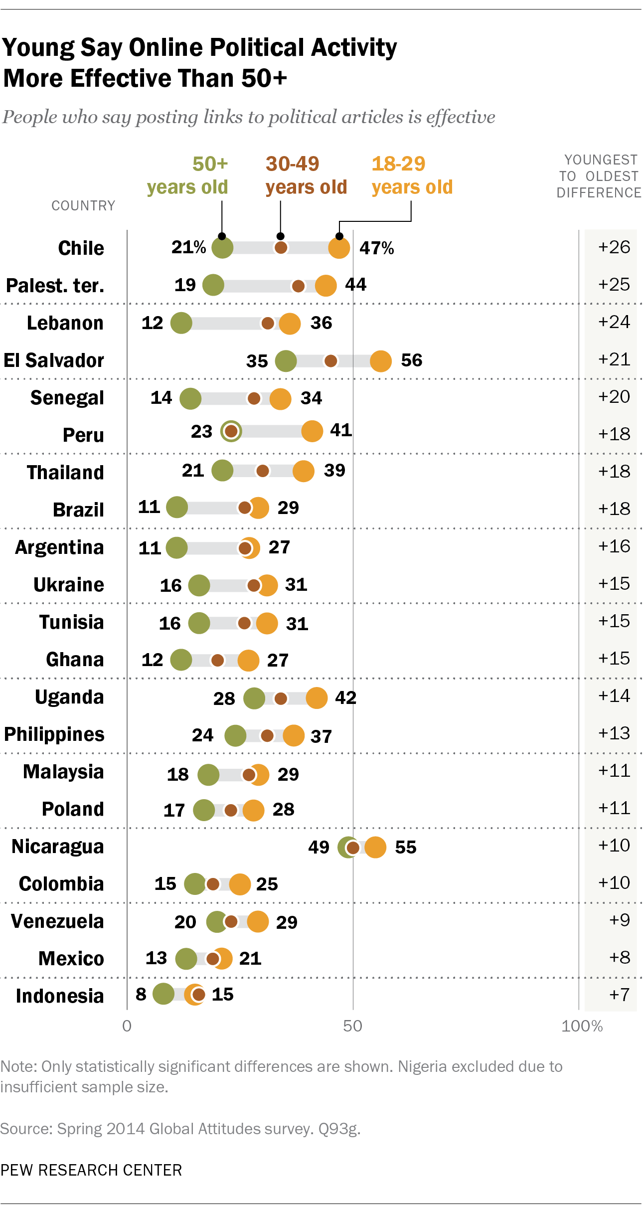
The two forms of online political activity tested on the survey are considered the least effective means of influencing what government does. Medians of only 27% see posting links to political articles online and posting online comments on political issues as useful tools of governmental change. In 24 countries, one of these online political activities has the lowest effectiveness rating of the political activities tested. While relatively low across all regions, online political participation is seen as somewhat more useful in Africa and the Middle East, where roughly a third view it as effective, compared with about a quarter of Asians and Latin Americans.
Like online political participation, in many countries internet users are much more likely than the general population to say online political activities are effective. For example, 40% of internet users in Tunisia say that posting links to political articles online is effective, compared with just 13% of the offline population.
Effectiveness of political activities is strongly related to participation in that activity. In all of the countries surveyed, those that say attending a political campaign or event is an effective way to influence the political system are also more likely to say that they have attended a political campaign or event. This relationship generally holds for all other political activities tested.

Age and Efficacy

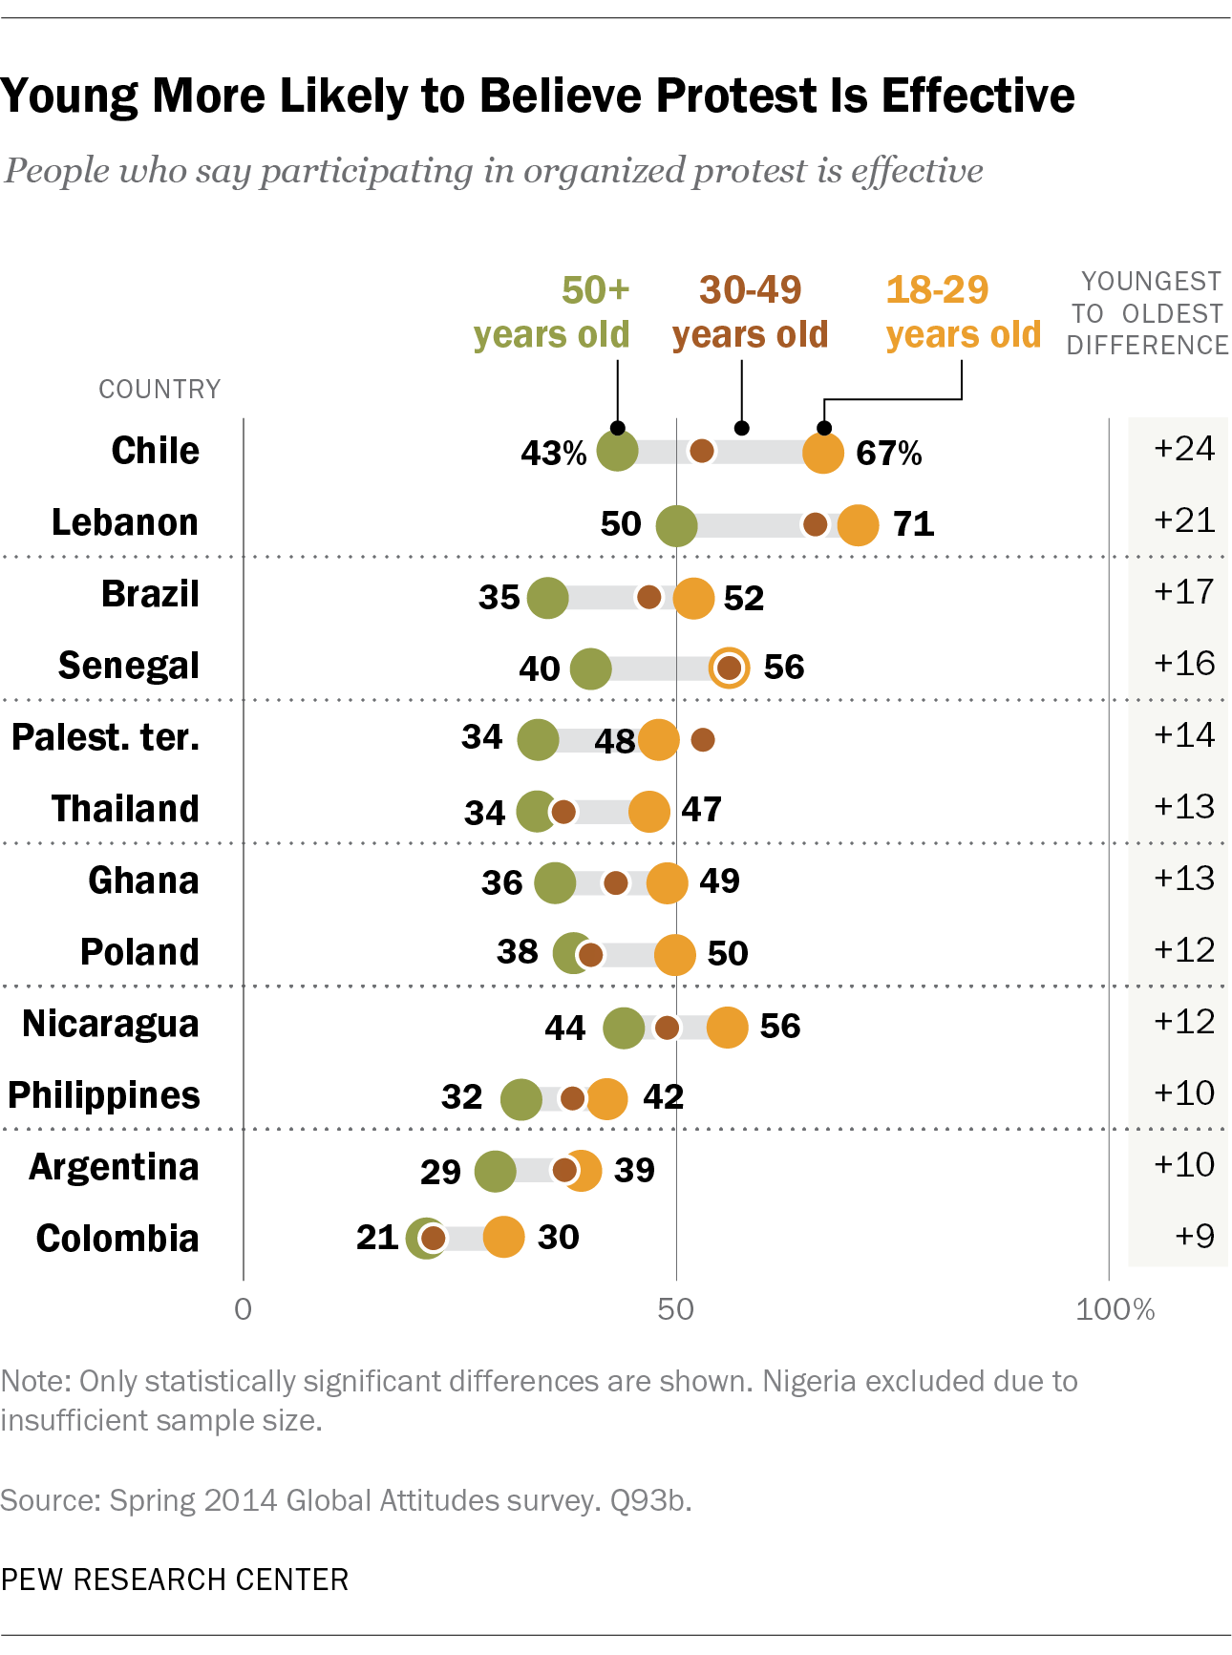
There are also age differences in the perceived effectiveness of certain political activities. In more than half of the countries surveyed, young people ages 18 to 29 are more likely than those 50 and older to say posting links online to political articles is effective (in all countries surveyed, young people also have higher levels of internet access). For example, in Lebanon, 36% of 18 to 29 year olds say posting links to political articles is an effective way to impact government while just 12% of those 50 and older say the same – a 24 point difference. Significant age gaps can also be found on views of the effectiveness of posting online political comments.
Though differences with those over 50 are less common among traditional political activities, in many countries young people are also more likely to think that forms of protest are effective ways to influence government. In 12 countries surveyed, young people are significantly more likely to say that participating in organized protests is an effective means of influencing government. Young people in 10 countries are also more likely than those 50 and older to say participating in labor strikes is effective. In Chile, where last year thousands of students joined protests to demand education reform, two-thirds of 18 to 29 year olds believe organized protests are affecting change in government while just 43% of those 50 and older agree. Large age differences also exist in Brazil, where widespread protests over social issues ranging from rising bus fares to the use of public funds for the World Cup, have plagued the country recently.
In addition to age, in some countries there are significant differences in perceived effectiveness of political action by education. Generally, when differences appear, highly educated individuals are more likely than less educated people to believe that political action is an effective means of influencing government.
For instance, two-thirds of highly educated Nigerians say attending campaign events is an effective political activity, while about half (51%) of those with less than a secondary education say the same. Differences in opinion by education also occur on the effectiveness of other political actions, especially in online political activities.

Methods in Detail
About the 2014 Spring Pew Global Attitudes Survey

Results for the survey are based on face-to-face interviews conducted under the direction of Princeton Survey Research Associates International. Survey results are based on national samples. For further details on sample designs, see below.

The descriptions below show the margin of sampling error based on all interviews conducted in that country. For results based on the full sample in a given country, one can say with 95% confidence that the error attributable to sampling and other random effects is plus or minus the margin of error. In addition to sampling error, one should bear in mind that question wording and practical difficulties in conducting surveys can introduce error or bias into the findings of opinion polls.

Country: Argentina
Sample design: Multi-stage cluster sample stratified by locality size
Mode: Face-to-face adults 18 plus
Languages: Spanish
Fieldwork dates: April 17 – May 11, 2014
Sample size: 1,000
Margin of Error: ±3.9 percentage points
Representative: Adult population (excluding dispersed rural population, or 6.5% of the population)

Country: Bangladesh
Sample design: Multi-stage cluster sample stratified by administrative division and urbanity
Mode: Face-to-face adults 18 plus
Languages: Bengali
Fieldwork dates: April 14 – May 11, 2014
Sample size: 1,000
Margin of Error: ±3.8 percentage points
Representative: Adult population

Country: Brazil
Sample design: Multi-stage cluster sample stratified by region and size of municipality
Mode: Face-to-face adults 18 plus
Languages: Portuguese
Fieldwork dates: April 10 – April 30, 2014
Sample size: 1,003
Margin of Error: ±3.8 percentage points
Representative: Adult population
Country: Chile
Sample design: Multi-stage cluster sample stratified by region and urbanity
Mode: Face-to-face adults 18 plus
Languages: Spanish
Fieldwork dates: April 25 – May 5, 2014
Sample size: 1,000
Margin of Error: ±3.8 percentage points
Representative: Adult population (excluding Chiloe and other islands, or about 3% of the population)

Country: China
Sample design: Multi-stage cluster sample stratified by region and urbanity
Mode: Face-to-face adults 18 plus
Languages: Chinese (Mandarin, Fuping, Renshou, Suining, Xichuan, Hua, Shanghai, Chenzhou, Anlong, Chengdu, Yingkou, Guang’an, Zibo, Jinxi, Yantai, Feicheng, Leiyang, Yuanjiang, Daye, Beijing, Yangchun, Nanjing, Shucheng, Linxia, Yongxin, Chun’an, Xinyang, Shangyu, Baiyin, Ruichang, Xinghua and Yizhou dialects)
Fieldwork dates: April 11 – May 15, 2014
Sample size: 3,190
Margin of Error: ±3.5 percentage points
Representative: Adult population (excluding Tibet, Xinjiang, Hong Kong and Macau, or about 2% of the population). Disproportionately urban. The data were weighted to reflect the actual urbanity distribution in China.
Note: The results cited are from Horizonkey’s self-sponsored survey.

Country: Colombia
Sample design: Multi-stage cluster sample stratified by region and urbanity
Mode: Face-to-face adults 18 plus
Languages: Spanish
Fieldwork dates: April 12 – May 8, 2014
Sample size: 1,002
Margin of Error: ±3.5 percentage points
Representative: Adult population (excluding region formerly called the National Territories and the islands of San Andres and Providencia, or about 4% of the population)

Country: Egypt
Sample design: Multi-stage cluster sample stratified by governorate and urbanity
Mode: Face-to-face adults 18 plus
Languages: Arabic
Fieldwork dates: April 10 – April 29, 2014
Sample size: 1,000
Margin of Error: ±4.3 percentage points
Representative: Adult population (excluding frontier governorates, or about 2% of the population)

Country: El Salvador
Sample design: Multi-stage cluster sample stratified by department and urbanity
Mode: Face-to-face adults 18 plus
Languages: Spanish
Fieldwork dates: April 28 – May 9, 2014
Sample size: 1,010
Margin of Error: ±4.5 percentage points
Representative: Adult population

Country: Ghana
Sample design: Multi-stage cluster sample stratified by region and settlement size
Mode: Face-to-face adults 18 plus
Languages: Akan (Twi), English, Dagbani, Ewe
Fieldwork dates: May 5 – May 31, 2014
Sample size: 1,000
Margin of Error: ±3.8 percentage points
Representative: Adult population

Country: India
Sample design: Multi-stage cluster sample stratified by region and urbanity
Mode: Face-to-face adults 18 plus
Languages: Hindi, Bengali, Tamil, Telugu, Marathi, Kannada, Gujarati, Odia
Fieldwork dates: April 14 – May 1, 2014
Sample size: 2,464
Margin of Error: ±3.1 percentage points
Representative: Adult population in 15 of the 17 most populous states (Kerala and Assam were excluded) and the Union Territory of Delhi (roughly 91% of the population). Disproportionately urban. The data were weighted to reflect the actual urbanity distribution in India.

Country: Indonesia
Sample design: Multi-stage cluster sample stratified by province and urbanity
Mode: Face-to-face adults 18 plus
Languages: Bahasa Indonesian
Fieldwork dates: April 17 – May 23, 2014
Sample size: 1,000
Margin of Error: ±4.0 percentage points
Representative: Adult population (excluding Papua and remote areas or provinces with small populations, or 12% of the population)

Country: Jordan
Sample design: Multi-stage cluster sample stratified by governorate and urbanity
Mode: Face-to-face adults 18 plus
Languages: Arabic
Fieldwork dates: April 11 – April 29, 2014
Sample size: 1,000
Margin of Error: ±4.5 percentage points
Representative: Adult population

Country: Kenya
Sample design: Multi-stage cluster sample stratified by province and settlement size
Mode: Face-to-face adults 18 plus
Languages: Kiswahili, English
Fieldwork dates: April 18 – April 28, 2014
Sample size: 1,015
Margin of Error: ±4.0 percentage points
Representative: Adult population

Country: Lebanon
Sample design: Multi-stage cluster sample stratified by region and urbanity
Mode: Face-to-face adults 18 plus
Languages: Arabic
Fieldwork dates: April 11 – May 2, 2014
Sample size: 1,000
Margin of Error: ±4.1 percentage points
Representative: Adult population (excluding a small area in Beirut controlled by a militia group and a few villages in the south of Lebanon, which border Israel and are inaccessible to outsiders, or about 2% of the population)

Country: Malaysia
Sample design: Multi-stage cluster sample stratified by state and urbanity
Mode: Face-to-face adults 18 plus
Languages: Bahasa Malaysia, Mandarin Chinese, English
Fieldwork dates: April 10 – May 23, 2014
Sample size: 1,010
Margin of Error: ±3.8 percentage points
Representative: Adult population (excluding difficult to access areas in Sabah and Sarawak, or about 7% of the population)

Country: Mexico
Sample design: Multi-stage cluster sample stratified by region and urbanity
Mode: Face-to-face adults 18 plus
Languages: Spanish
Fieldwork dates: April 21 – May 2, 2014
Sample size: 1,000
Margin of Error: ±4.0 percentage points
Representative: Adult population

Country: Nicaragua
Sample design: Multi-stage cluster sample stratified by department and urbanity
Mode: Face-to-face adults 18 plus
Languages: Spanish
Fieldwork dates: April 23 – May 11, 2014
Sample size: 1,008
Margin of Error: ±4.0 percentage points
Representative: Adult population (excluding residents of gated communities and multi-story residential buildings, or less than 1% of the population)

Country: Nigeria
Sample design: Multi-stage cluster sample stratified by region and urbanity
Mode: Face-to-face adults 18 plus
Languages: English, Hausa, Yoruba, Igbo
Fieldwork dates: April 11 – May 25, 2014
Sample size: 1,014
Margin of Error: ±4.3 percentage points
Representative: Adult population (excluding Adamawa, Borno, Cross River, Jigawa, Yobe and some areas in Taraba, or roughly 12% of the population)

Country: Pakistan
Sample design: Multi-stage cluster sample stratified by province and urbanity
Mode: Face-to-face adults 18 plus
Languages: Urdu, Pashto, Punjabi, Saraiki, Sindhi
Fieldwork dates: April 15 – May 7, 2014
Sample size: 1,203
Margin of Error: ±4.2 percentage points
Representative: Adult population (excluding the Federally Administered Tribal Areas, Gilgit-Baltistan, Azad Jammu and Kashmir for security reasons, areas of instability in Khyber Pakhtunkhwa [formerly the North-West Frontier Province] and Baluchistan, military restricted areas and villages with less than 100 inhabitants – together, roughly 18% of the population). Disproportionately urban. The data were weighted to reflect the actual urbanity distribution in Pakistan.

Country: Palestinian territories
Sample design: Multi-stage cluster sample stratified by region and urban/rural/refugee camp population
Mode: Face-to-face adults 18 plus
Languages: Arabic
Fieldwork dates: April 15 – April 22, 2014
Sample size: 1,000
Margin of Error: ±4.4 percentage points
Representative: Adult population (excluding Bedouins who regularly change residence and some communities near Israeli settlements where military restrictions make access difficult, or roughly 5% of the population)

Country: Peru
Sample design: Multi-stage cluster sample stratified by region and urbanity
Mode: Face-to-face adults 18 plus
Languages: Spanish
Fieldwork dates: April 11 – May 2, 2014
Sample size: 1,000
Margin of Error: ±4.0 percentage points
Representative: Adult population

Country: Philippines
Sample design: Multi-stage cluster sample stratified by region and urbanity
Mode: Face-to-face adults 18 plus
Languages: Tagalog, Cebuano, Ilonggo, Ilocano, Bicolano
Fieldwork dates: May 1 – May 21, 2014
Sample size: 1,008
Margin of Error: ±4.0 percentage points
Representative: Adult population

Country: Poland
Sample design: Multi-stage cluster sample stratified by province and urbanity
Mode: Face-to-face adults 18 plus
Languages: Polish
Fieldwork dates: March 17 – April 8, 2014
Sample size: 1,010
Margin of Error: ±3.6 percentage points
Representative: Adult population

Country: Russia
Sample design: Multi-stage cluster sample stratified by Russia’s eight geographic regions, plus the cities of Moscow and St. Petersburg, and by urban-rural status.
Mode: Face-to-face adults 18 plus
Languages: Russian
Fieldwork dates: April 4 – April 20, 2014
Sample size: 1,000
Margin of Error: ±3.6 percentage points
Representative: Adult population (excludes Chechen Republic, Ingush Republic and remote territories in the Far North – together, roughly 3% of the population)

Country: Senegal
Sample design: Multi-stage cluster sample stratified by region and urbanity
Mode: Face-to-face adults 18 plus
Languages: Wolof, French
Fieldwork dates: April 17 – May 2, 2014
Sample size: 1,000
Margin of Error: ±3.7 percentage points
Representative: Adult population

Country: South Africa
Sample design: Multi-stage cluster sample stratified by metropolitan area, province and urbanity
Mode: Face-to-face adults 18 plus
Languages: English, Zulu, Xhosa, South Sotho, Afrikaans, North Sotho
Fieldwork dates: May 18 – June 5, 2014
Sample size: 1,000
Margin of Error: ±3.5 percentage points
Representative: Adult population

Country: Tanzania
Sample design: Multi-stage cluster sample stratified by region and urbanity
Mode: Face-to-face adults 18 plus
Languages: Kiswahili
Fieldwork dates: April 18 – May 7, 2014
Sample size: 1,016
Margin of Error: ±4.0 percentage points
Representative: Adult population (excluding Zanzibar, or about 3% of the population)

Country: Thailand
Sample design: Multi-stage cluster sample stratified by region and urbanity
Mode: Face-to-face adults 18 plus
Languages: Thai
Fieldwork dates: April 23 – May 24, 2014
Sample size: 1,000
Margin of Error: ±3.9 percentage points
Representative: Adult population (excluding the provinces of Narathiwat, Pattani and Yala, or about 3% of the population)

Country: Tunisia
Sample design: Multi-stage cluster sample stratified by governorate and urbanity
Mode: Face-to-face adults 18 plus
Languages: Tunisian Arabic
Fieldwork dates: April 19 – May 9, 2014
Sample size: 1,000
Margin of Error: ±4.0 percentage points
Representative: Adult population

Country: Turkey
Sample design: Multi-stage cluster sample stratified by region, urbanity and settlement size
Mode: Face-to-face adults 18 plus
Languages: Turkish
Fieldwork dates: April 11 – May 16, 2014
Sample size: 1,001
Margin of Error: ±4.5 percentage points
Representative: Adult population

Country: Uganda
Sample design: Multi-stage cluster sample stratified by region and urbanity
Mode: Face-to-face adults 18 plus
Languages: Luganda, English, Runyankole/Rukiga, Luo, Runyoro/Rutoro, Ateso, Lugbara
Fieldwork dates: April 25 – May 9, 2014
Sample size: 1,007
Margin of Error: ±3.9 percentage points
Representative: Adult population

Country: Ukraine
Sample design: Multi-stage cluster sample stratified by Ukraine’s six regions plus ten of the largest cities – Kyiv (Kiev), Kharkiv, Dnipropetrovsk, Odessa, Donetsk, Zaporizhia, Lviv, Kryvyi Rih, Lugansk and Mikolayev – as well as three cities on the Crimean peninsula – Simferopol, Sevastopol and Kerch.
Mode: Face-to-face adults 18 plus
Languages: Russian, Ukrainian
Fieldwork dates: April 5 – April 23, 2014
Sample size: 1,659
Margin of Error: ±3.3 percentage points
Representative: Adult population (Survey includes oversamples of Crimea and of the South, East and Southeast regions. The data were weighted to reflect the actual regional distribution in Ukraine.)

Country: Venezuela
Sample design: Multi-stage cluster sample stratified by region and parish size
Mode: Face-to-face adults 18 plus
Languages: Spanish
Fieldwork dates: April 11 – May 10, 2014
Sample size: 1,000
Margin of Error: ±3.5 percentage points
Representative: Adult population (excluding remote areas, or about 4% of population)

Topline Results
Pew Research Center
Spring 2014 survey
December 18, 2014 Release

Methodological notes:

- Survey results are based on national samples. For further details on sample designs, see Survey Methods section.

- Due to rounding, percentages may not total 100%. The topline “total” columns show 100%, because they are based on unrounded numbers.

- Not all questions included in the Spring 2014 survey are presented in this topline. Omitted questions have either been previously released or will be released in future reports.

Participation is measured using a 10-item index ranging from 0-10, with “10” representing the highest political participation. Respondents were coded as “1” if they say they have done a particular political activity; “.5” if they say they have not done, but might do, a particular political activity; and “0” if they say they have not and would never do a particular political activity. Those who reply “Don’t know” to any of the ten items are excluded from the participation index. The percentage of those excluded from the index was particularly high in India where 38% replied “Don’t know” to one or more of the political activity questions. Tanzania and Thailand are excluded from the participation index since observations were not available for all 10 activities. The political activities include attending a political campaign speech or event, participating in an organized protest, being an active member of a political organization, phoning a live radio or TV show to express an opinion, voting in an election, participating in labor strikes, posting links to political stories or articles for others to read online, posting thoughts or comments on political or social issues online, contacting a government official and signing a petition about a political or social issue. Participation questions were not asked in China.
Respondents in the United States were asked whether “elected officials care what people like me think” while respondents elsewhere were asked if “government officials care what people like me think.”

